COLLEGE OF INFORMATION TECHNOLOGY

UNIVERSITI TENAGA NASIONAL

UNITEN E-CAR RENTAL

NOR NATASHA BINTI ABD AZIS

2014

UNITEN E-CAR RENTAL

by

NOR NATASHA BINTI ABD AZIS

Project Supervisor: Aliza Abdul Latif

A REPORT SUBMITTED IN PARTIAL FULFILLMENT OF THE

REQUIREMENTS FOR THE BACHELOR IN INFORMATION

TECHNOLOGY, DEPARTMENT OF INFORMATICS, COLLEGE

OF INFORMATION TECHNOLOGY, UNIVERSITI TENAGA

NASIONAL

2014

DECLARATION

I hereby declare that this report, submitted to Universiti Tenaga Nasional as a partial fulfilment of the requirements for the Bachelor of Information Technology has not been submitted as an exercise for a degree at any other university. I also certify that the work described here is entirely my own except for excerpts and summaries whose sources are appropriately cited in the references.

This report may be made available within the university library and may be photocopied or loaned to other libraries for the purposes of consultation.

13 January 2014

NOR NATASHA BINTI ABD AZIS

IS088940

Approval Sheet

This thesis entitled:

“UNITEN E-Car Rental”

submitted by

NOR NATASHA BINTI ABD AZIS (IS 088940)

In requirement for the degree of Bachelor of Information Technology, College Of Information Technology, University Tenaga Nasional has been accepted.

Supervisor: Aliza Abdul Latif

Signature: ………………….

Date: 13th January 2014

ABSTRACT

The system is designed to be used by UNITEN student. It is an online system thru which students can register, browse through available cars and make reservation. It is developed to help the student to get from one place to another by offering affordable rates from different car rental companies.

The system acts as a platform where different car rental companies are joined together in order to provide different types of cars and affordable price range. Student can compare the rates and choose what is best for them. The car rental company will update the availability of their cars and will contact the student directly once the reservation process is done.

Current car rental systems in universities only do brochure/flyers advertising and this make it difficult for student to search for available cars. The reservation process is also time consuming where student need to contact the car rental company to find out information in order to contract out for a vehicle. The system aims to increase customer retention and simplify vehicle and staff management.

The objectives of the system are to produce a web-based system that allows student to reserve car online and to ease the student task when they need to rent a car. It will also help the car rental companies to effectively manage their car rental business.

TABLE OF CONTENTS

Page

DECLARATION ii

APPROVAL SHEET iii

ABSTRACT iv

TABLE OF CONTENTS v

LIST OF TABLES vi

LIST OF FIGURES ix

CHAPTER 1: INTRODUCTION

* 1. Background 1
  2. Problem Statement 2
  3. Objective 3
  4. Scope 4

CHAPTER 2: ANALYSIS & SYSTEM REQUIREMENTS

2.1 Review of Current and Similar System(s) 6

2.2 Software Development Methodology 10

2.3 Requirement Gathering Techniques 13

2.4 Tools and Technology 18

CHAPTER 3: DESIGN

3.1 Diagrams 20

3.2 Application Interface Design 27

CONCLUSION 30

APPENDICES 31

APPENDIX A: Project Timeline-Gantt Chart

APPENDIX B: Requirement Survey

LIST OF TABLES

Table No. Page

2.1 Comparison of functionalities 8

3.4.1 Database Design-Student 25

3.4.2 Database Design-Administrator 25

3.4.3 Database Design-Car Rental Company 25

3.4.4 Database Design-Reservation 26

3.4.5 Database Design-Car Details 26

LIST OF FIGURES

Figure No. Page

2.1.1 Interface of Hawk Rent A Car 6

2.1.2 Interface of Imtra Car Rental 7

2.1.3 Interface of Malaysia Car Rental 7

2.1.4 Current car rental system 9

2.2 The Waterfall Model 10

2.3.1 Pie Chart-Gender 13

2.3.2 Pie Chart-Online Car Rental System 14

2.3.3 Pie Chart-Reservation Method 14

2.3.4 Pie-Chart-Frequency 15

2.3.5 Pie-Chart-Purpose 15

2.3.6 Pie Chart-Current Website 16

2.3.7 Pie Chart-User Sign In 16

2.3.8 Pie Chart-Features 17

3.1.1 Entity-Relationship Diagram 20

3.2.1 Flowchart-User’s Perspective 21

3.2.2 Flowchart-Admin’s Perspective 22

3.2.3 Flowchart-Company’s Perspective 23

3.3 Data Structure Diagram 24

3.5.1 Interface-About Us 27

3.5.2 Interface-Reservation 28

3.5.3 Interface-Cars Detail 29

CHAPTER I

INTRODUCTION

* 1. Background

A car rental or car hire agency is a company that rents vehicles for short periods of time (generally ranging from a few hours to a few weeks) for a fee. It is often organized with numerous local branches (which allow a user to return a vehicle to a different location), and primarily located near airports or busy city areas and often complemented by a website allowing online reservations.

The UNITEN E-Car Rental system is designed specifically to be used by UNITEN student. It is an online system where students can register, browse through available cars and make reservation. It is developed to help student to get to one place and another by offering affordable price range for students from different car rental companies.

The system acts as a platform where different car rental companies are joined together in order to provide different types of cars and affordable rates. Student can compare between all the car rental companies and choose what is best for them. The car rental company will update the availability of their cars and will contact the student directly once the reservation process is done.

* 1. Problem Statement

Current car rental system in UNITEN only do brochure/flyers advertising and this make it difficult for student to search for available cars. The reservation process is also time consuming where student need to contact the car rental company to find out more information in order to contract out for a vehicle.

Although there are several car rental companies out there that has provide online car rental system, the car’s rates is not within the reach of student’s pocket money. By developing this system, it is guarantee that the price offered by the car rental companies is affordable as it is develop specially for the student.

The current car rental system is not eco-friendly as the monitoring of the vehicle activity and overall business use lots of paper work compared to an online reservation system. The UNITEN E-Car Rental system will help to overcome these problems and make the process easy and increase the efficiency at offering quality service for student.

* 1. Objectives

This system is develop in order

* To produce a web-based system that allows UNITEN student to reserve cars online.
* To increase customer retention and to simplify the management of staff and vehicles.
* To help car rental companies to effectively manage their car rental business.
* To help ease student task when they need to rent for cars.
* To saves time, reduce cost and labour.
  1. Scope
     1. System Scopes

The functionalities of the system:

* Student’s registration

A registration portal to handle students details and monitors their transaction. Through this function, the student can sign in to the system if they have already registered with the system or have previously used the system. If not, the student can just sign up as a new user and fill in the required information.

* Online vehicle reservation

Student can browse for available cars and compare the rates offered by the car rental companies. In this system, there will be 3 different car rental companies at which all the companies will provide types of cars that are suitable for students (example: Proton and Perodua). Student can also reserve cars online prior to their expected pick-up date and time.

The system is a platform for the student to communicate with car rental companies where once the reservation process is done, the car rental company will contact the student directly.

* Student and companies details

The administrator of the system will manage and handle the student’s and companies’ details.

* + 1. User Scopes

Types of users who will be using the system are:

* Student
* Sign in/sign up
* Browse through available cars
* Make reservation
* View/edit reservation
* Administrator
* Sign in
* Manage student and car rental companies details
* Car Rental Company
* Sign in
* Update details on cars availability
* Manage reservation details
* Contact user directly regarding reservation

CHAPTER II

ANALYSIS & SYSTEM REQUIREMENTS

2.1 Review of Current and Similar System(s)

Similar systems:

There are many car rental website on the internet nowadays. However, these website are more suitable for professionals or career people. The prices they offer are not within the reach for students. UNITEN E-Car Rental offers affordable price for student who need to rent a car to get to one place or another.

Nevertheless, there are still several systems that have similar features as the proposed system.

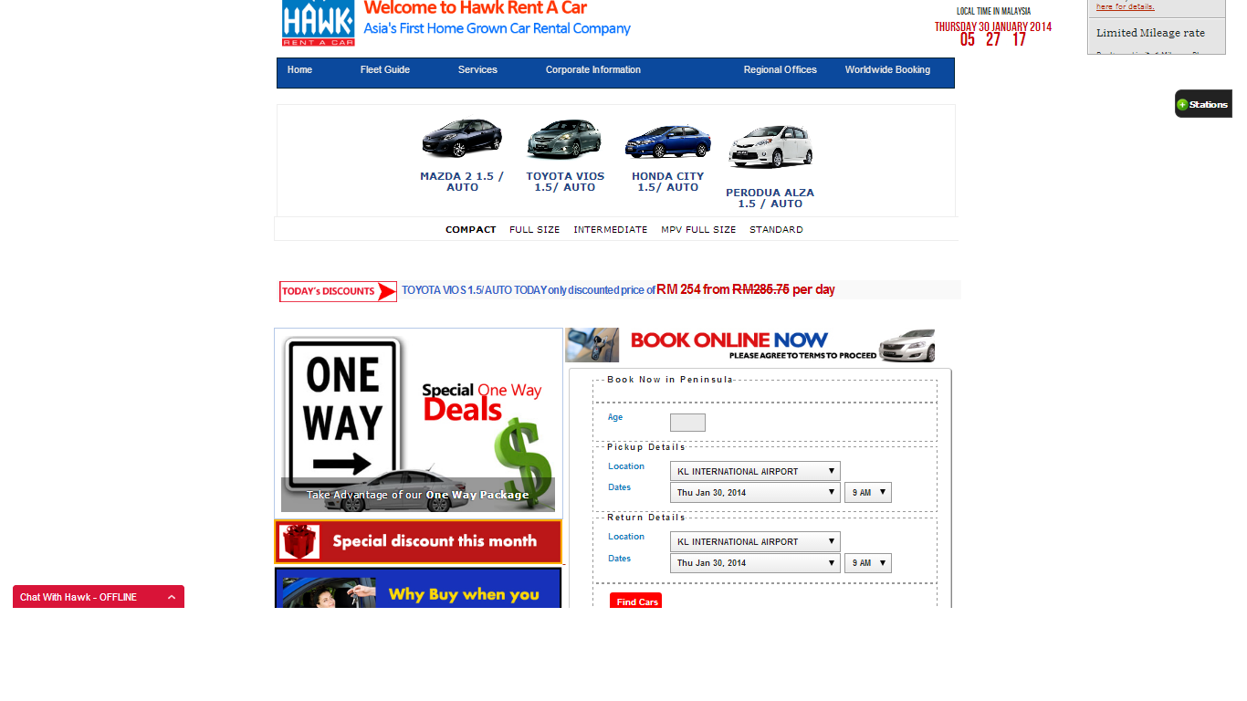

Figure 2.1.1 shows the interface of Hawk Rent A Car online system.

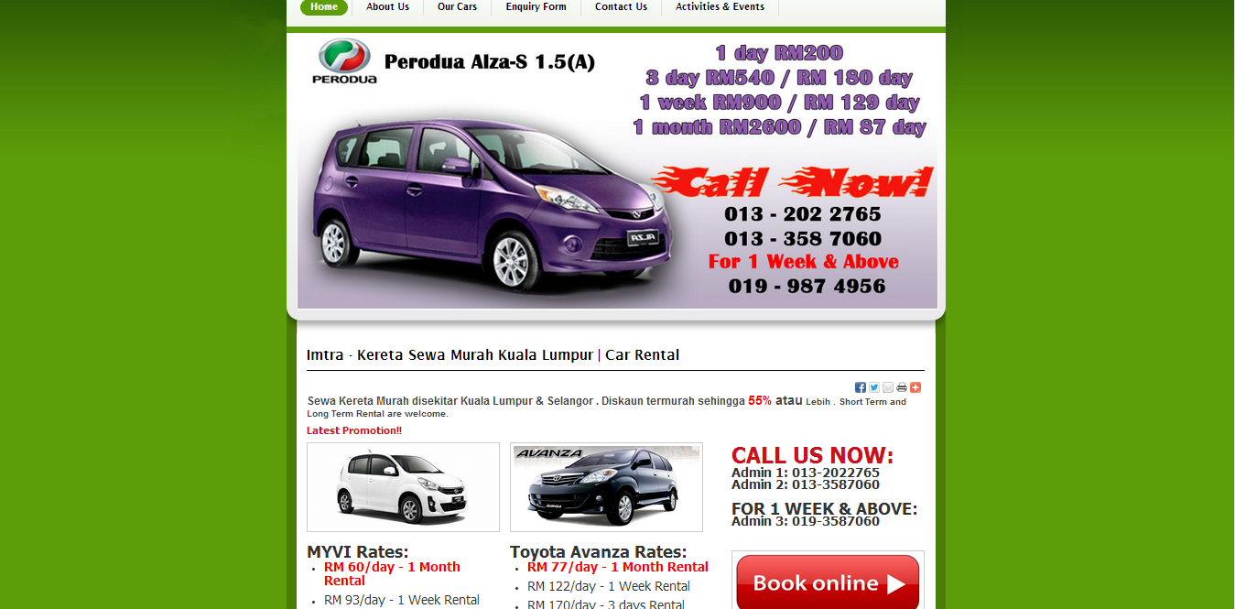

Figure 2.1.2 shows the interface of Imtra Car Rental online system.

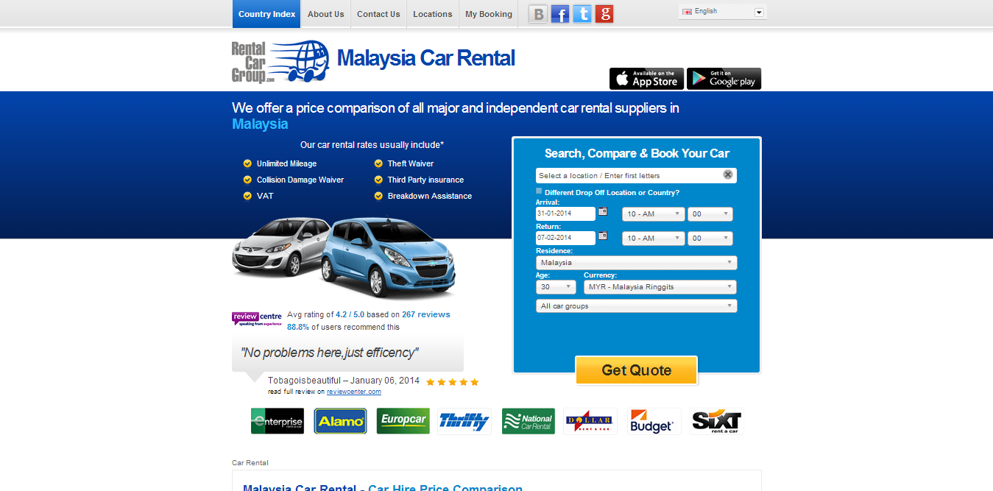

Figure 2.1.3 shows the interface of Malaysia Car Rental online system.

Comparison of functionalities between similar and proposed system:

|  |  |  |  |  |
| --- | --- | --- | --- | --- |
|  | Hawk Rent A Car | Imtra Car Rental | Malaysia Car Rental | UNITEN E-Car Rental |
| User sign in | X | X | X |  |
| Types of cars |  |  | X |  |
| Reservation details |  | X |  |  |
| Partners details | X | X |  |  |
| Car rates | X |  | X |  |
| Contact us | X |  |  |  |
| Language supported | English | English, Bahasa Malaysia | Multi-language | English |

Table 2.1 shows the comparison of functionalities between Hawk Rent A Car, Imtra Car Rental, Malaysia Car Rental and UNITEN E-Car Rental.

Current system:

Apart from online system, some car rental companies use other approaches such as distributing flyers and brochure advertising on bulletin board. This may be difficult for students to browse through available cars or to view their reservation details.

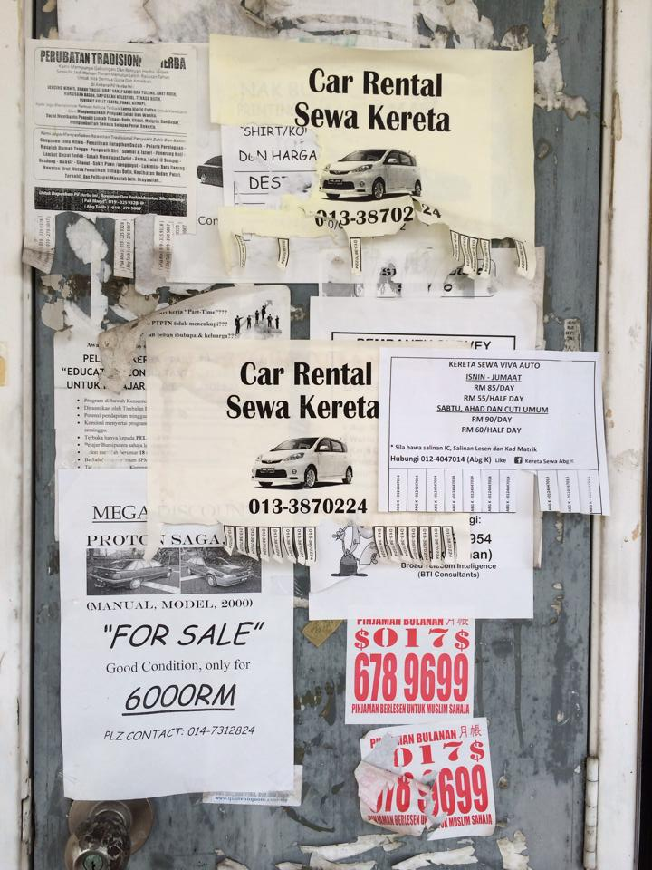

Figure 2.1.4 shows how current car rental system are approached; through the use of brochure advertising and flyers.

2.2 Software Development Methodology

A software development methodology is a framework that is used to structure, plan, and control the process of developing an information system. Common methodologies include waterfall, prototyping, iterative and incremental development, spiral development, rapid application development, and extreme programming.

In the development of this system, the chosen methodology is the waterfall model. The waterfall model is a sequential design process, often used in software development processes, in which progress is seen as flowing steadily downwards (like a waterfall) through the phases of analysis, requirements, design, implementation, testing and maintenance.

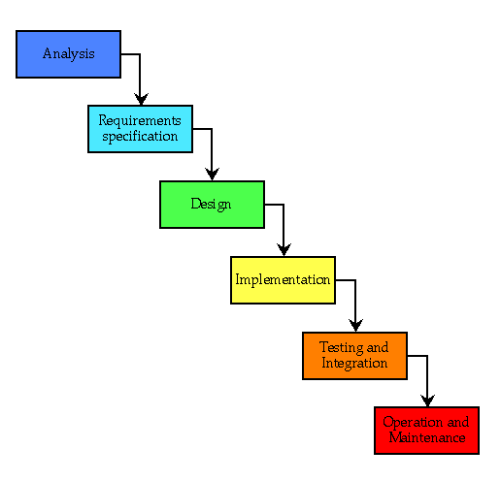

Figure 2.2 shows the Waterfall Model.

**Analysis**

* Analysing problem faced by students where current car rental system in UNITEN is time consuming. There are no online systems to ease their reservation. The problem is studied and several approaches are to be taken to solve the problem.

**Requirements**

* A survey is conducted to 50 people (student and non-student) in order to capture the requirements for the development of UNITEN E-Car Rental. The results are documented to assist in developing the proposed system.

**Design**

* The requirement are specified and then followed by the design of the system. This phase helps in determining the system architecture. The system design should have features that enable the user to register, browse through available cars and make reservation. The system should also enable the admin to manage the user details and handling the reservation process efficiently. Apart from that, the system should be user friendly and easy to use.

**Implementation**

* The writing of the codes will take place during this phase; it involves establishing some form of command for execution. This phase has to be customized according to the specific requirements. In order to develop the system, PHP (Hypertext Preprocessor), MySQL and HTML (HyperText Markup Language) will be used.

**Testing**

* The process of executing the system to find any errors or defects. Software testing can be defined as the process of validating and verifying that the system meets the requirement that guided the design and development.

**Maintenance**

* The modification of a software product after delivery to correct faults, to improve performance or other attributes.

2.3 Requirement Gathering Techniques

In order to gather the requirements to assist the development of the proposed system, data were collected by conducting a survey; questionnaire to 30 students. The questionnaire was distributed manually and online. 10 questions were asked to the student.

The survey is a series of questions asked to obtain statistically useful information regarding the proposed system. It is a valuable method of collecting a wide range of information from a large number of individuals, often referred to as respondents.

1. Gender

Figure 2.3.1 shows the Gender proportion.

1. Occupation

The survey is distributed to all 30 students in order to gather the data.

1. Age

The respondents (students) age range is from 18 to 25 years old whom all is eligible to own a driving license.

1. Have you use any online car rental system before?If no, skip to question 8.

Figure 2.3.2 shows amount of student who have use online car rental system.

1. How did you book/reserve your last hire car? Please choose one of the following options**:**

Figure 2.3.3 shows how student reserve their last hire car.

1. How often do you rent a vehicle?

Figure 2.3.4 shows how often student rent for vehicle.

1. Do you rent MOSTLY for:

Figure 2.3.5 shows what student rent mostly for.

1. Do you think the information on current car rental website is adequate?

Figure 2.3.6 shows how many students agree that information on current car rental website is adequate.

1. Do you think user registration (sign in) is necessary?

Figure 2.3.7 shows amount of students who think user sign in is necessary.

1. What features would you like to see in the system? You may tick more than one.

Figure 2.3.8 shows the features students would like to have in the system.

2.4 Tools and Technology

The tools and technology that will be used in developing UNITEN E-Car Rental system are as follows:

* PHP (Hypertext Preprocessor)
* HTML (HyperText Markup Language)
* MySQL
* CSS (Cascading Style Sheet)
* Microsoft Visual Studio

**PHP (Hypertext Preprocessor)**

* PHP code is interpreted by a web server with a PHP processor module, which generates the resulting web page. PHP commands can be embedded directly into an HTML source document rather than calling an external file to process data.

**HTML (HyperText Markup Language)**

* HTML allows images and objects to be embedded and can be used to create interactive forms. It will help to standardize the system in terms of its font, colour, graphic or hyperlinks.

**MySQL**

* MySQL is a popular choice of database for use in web applications and open source web application software that require a full-featured database management system. It provides reliable, high-performance and scalable database application.

**CSS (Cascading Style Sheet)**

* CSS is designed primarily to enable the separation of document content from document presentation, including elements such as the layout, colours and fonts. This separation can improve content accessibility, provide more flexibility.

**Microsoft Visual Studio**

* It is used to develop console and graphical user interface application. It supports nearly any programming language.

CHAPTER III

DESIGN

3.1 ERD (Entity-Relationship Diagram)

An Entity-Relationship Diagram is a graphical representation of entities and their relationships to each other, typically used in computing in regard to the organization of data within databases or information systems. An entity is a piece of data; an object or concept about which data is stored.

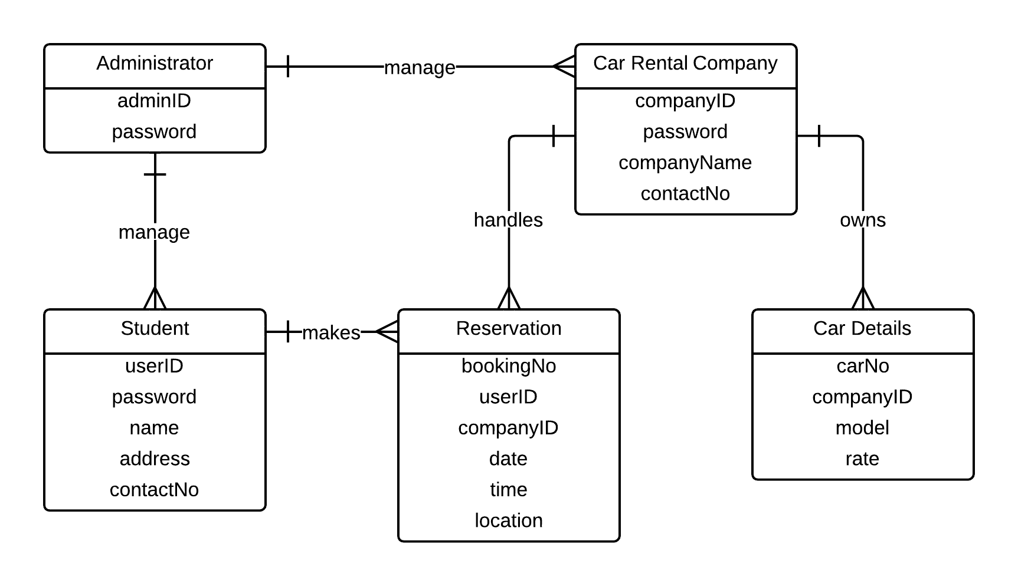

Figure 3.1.1 shows ERD of UNITEN E-Car Rental

The figure 3.1 shows that the student and car rental company details are managed by the admin. The car rental company will handle the reservation process and will contact the user directly once the reservation has been made. The car details belong to each representative car rental company.

3.2 Data Flow Chart

A flowchartis a type of diagram that represents an algorithm or process, showing the steps as boxes of various kinds, and their order by connecting them with arrows. This diagrammatic representation illustrates a solution to a given problem. Flowcharts are used in analysing, designing, documenting or managing a process or program in various fields.

3.2.1 User’s perspective

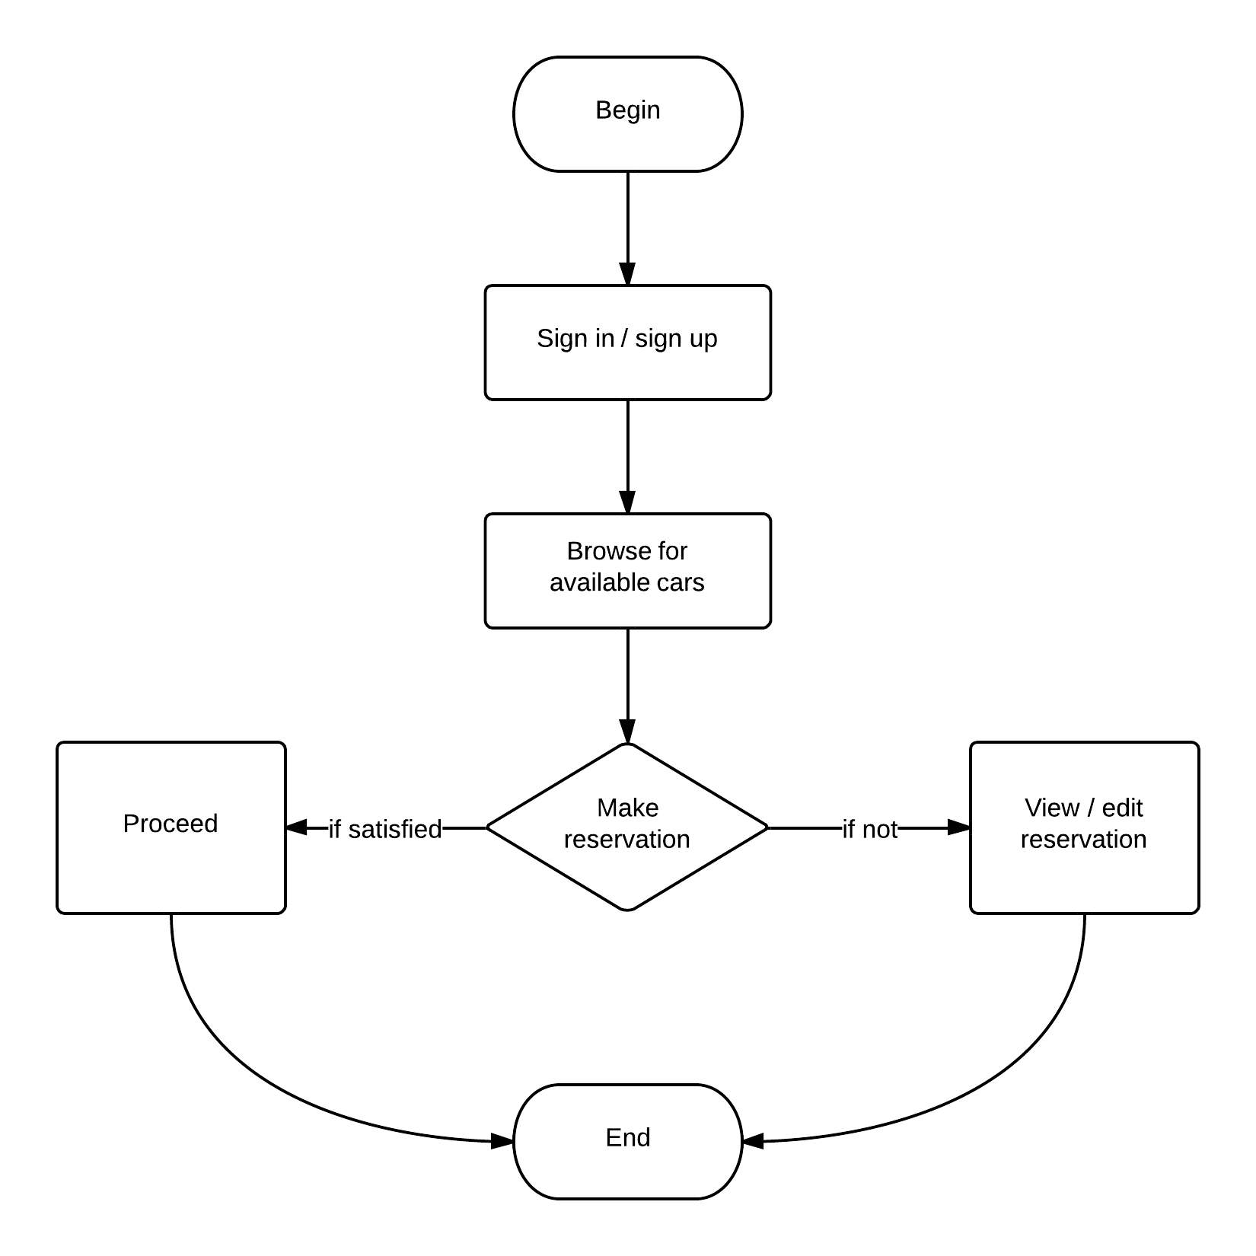

Figure 3.2.1 shows the Flowchart from user’s perspective of UNITEN E-Car Rental

The figure 3.2.1 shows the user’s activity to reserve a car step by step. First, user needs to sign in/sign up (for new user) to browse through available cars provided by the car rental agency. Once they’ve made their choice they can proceeds to the reservation or view and edit the reservation made earlier. The payment method will be made once the car is delivered.

3.2.2 Administrator’s perspective

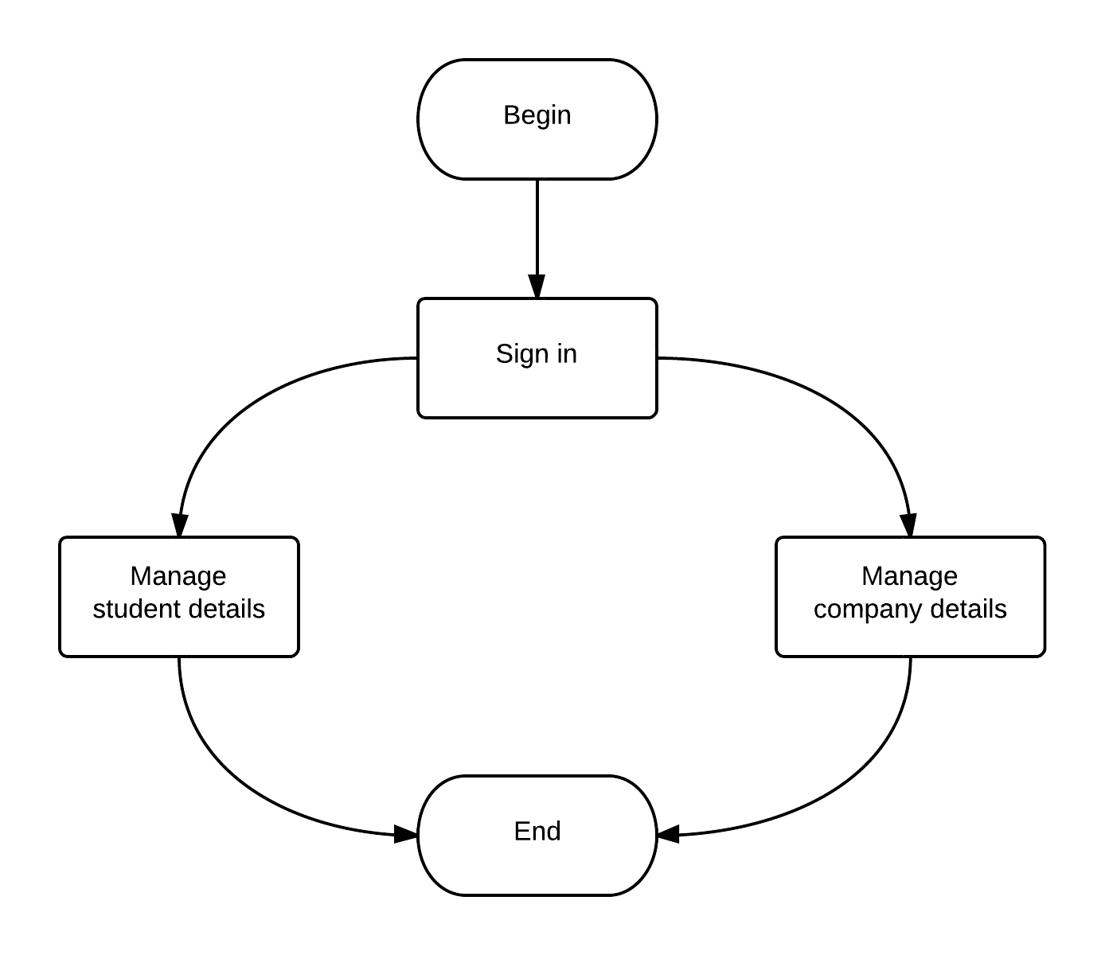

Figure 3.2.2 shows the Flowchart from admin’s perspective of Uniten E-Car Rental

The figure 3.2.2 shows the admin’s activity. Admin needs to sign in in order to view and manage (edit or delete) the student and company details.

3.2.3 Company’s perspective

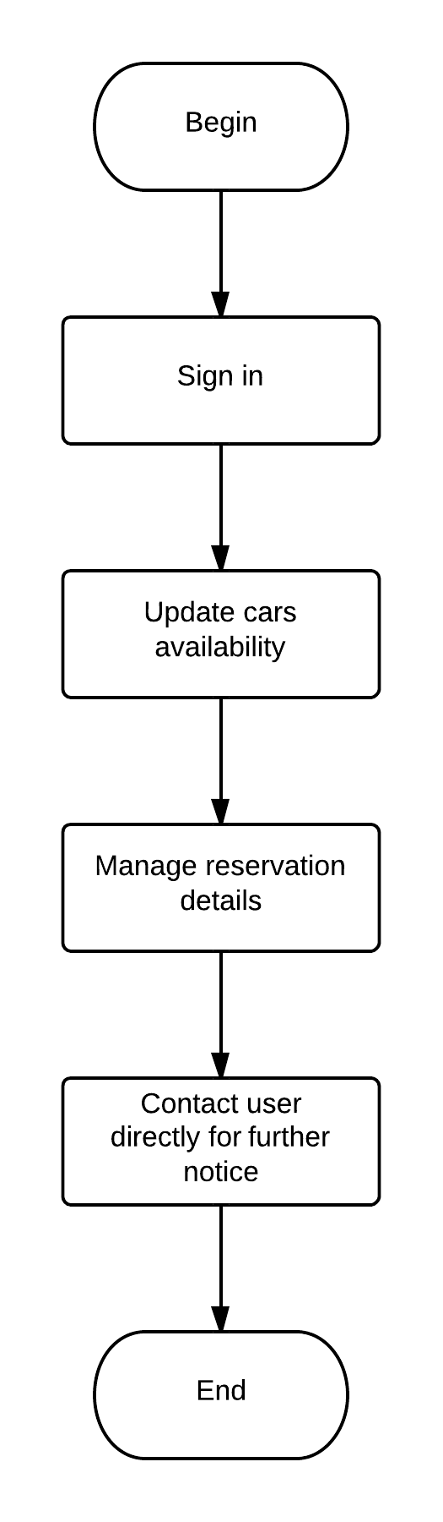

Figure 3.2.3 shows the Flowchart from the company’s perspective of UNITEN E-Car Rental

The figure 3.2.3 shows what the car rental agency can do. They are able to update details about the cars they offered. After a user made reservation, the car rental agency will then manage the reservation details and will then contact the user directly for further steps (delivery/pick up location).

* 1. Data Structure Diagram

Data Structure Diagram is a diagram of the conceptual data model which documents the entities and their relationships, as well as the constraints that connect to them. The basic graphic notation elements of DSDs are boxes which represent entities. The arrow symbol represents relationships. Data structure diagrams are most useful for documenting complex data entities.

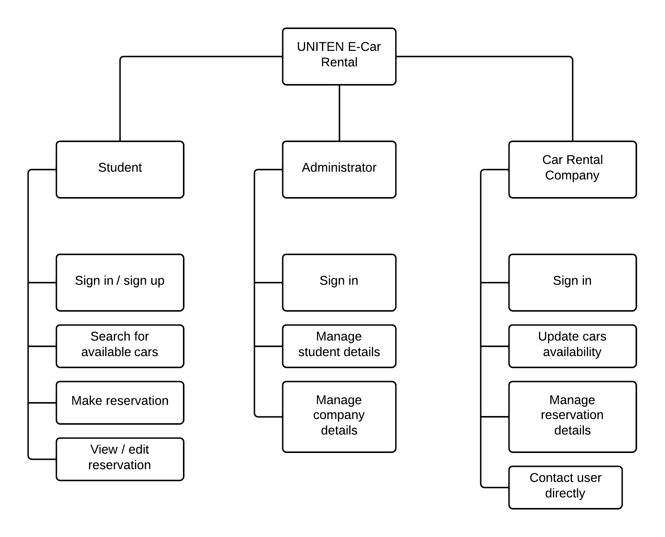

Figure 3.3 shows the Structure Diagram of UNITEN E-Car Rental

The figure 3.3 shows the scope student, administrator, and company) and the task they do. Each scope has different functions in the system.

* 1. Database Design

Database design is the process of producing a detailed data model of a database. It contains all the needed logical and physical design choices and physical storage parameters needed to generate a design in a Data Definition Language, which can then be used to create a database. A fully attributed data model contains detailed attributes for each entity.

For UNITEN E-Car Rental system, there are a total of 5 database tables.

Table 3.4.1: Student

|  |  |  |
| --- | --- | --- |
| **Field** | **Data Type** | **Description** |
| userID | varchar | ID of user |
| password | varchar | password of user |
| name | char(50) | name of user |
| address | varchar(50) | address of user |
| contactNo | numeric(10) | contact number of user |

Table 3.4.2: Administrator

|  |  |  |
| --- | --- | --- |
| **Field** | **Data Type** | **Description** |
| adminID | varchar | admin’s ID |
| password | varchar | admin’s password |

Table 3.4.3: Car Rental Company

|  |  |  |
| --- | --- | --- |
| **Field** | **Data Type** | **Description** |
| companyID | varchar | ID of company |
| password | varchar | company’s password |
| companyName | char(50) | name of company |
| contactNo | numeric(10) | company’s contact number |

Table 3.4.4: Reservation

|  |  |  |
| --- | --- | --- |
| **Field** | **Data Type** | **Description** |
| bookingNo | numeric(10) | user’s booking number |
| userID | varchar | user’s ID |
| companyID | varchar | company’s ID |
| date | date | reservation’s date |

Table 3.4.5: Car Details

|  |  |  |
| --- | --- | --- |
| **Field** | **Data Type** | **Description** |
| carNo | varchar | car’s plate number |
| companyID | varchar | company’s ID |
| model | varchar | type of car |
| rate | varchar | car’s price rate |

* 1. Application Interface Design

Interface design deals with the process of developing a method for two (or more) modules in a system to connect and communicate. These modules can apply to hardware, software or the interface between a user and a machine.

The UNITEN E-Car Rental system provides interface design which is as simple and efficient as possible and is user friendly.

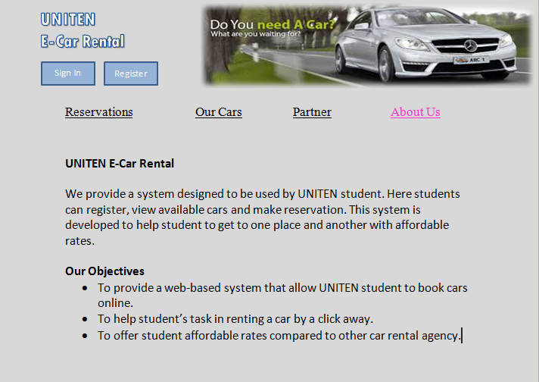

Figure 3.5.1 shows the About Us page of UNITEN E-Car Rental

The figure 3.5.1 shows the information and the objectives of the proposed UNITEN E-Car Rental system.

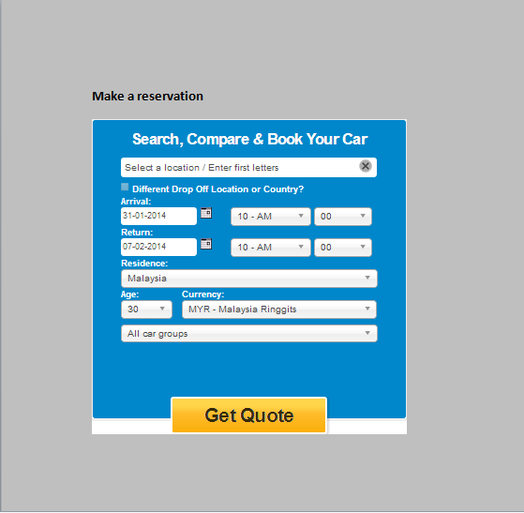

Figure 3.5.2 shows the reservation page of UNITEN E-Car Rental

The figure 3.5.2 is where the reservation process takes place. Here, the user will enter the reservation details and also the types of car they prefer.

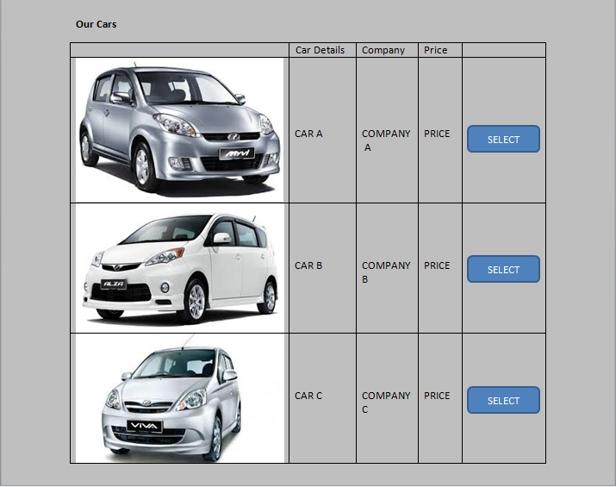

Figure 3.5.3 shows the car details page of UNITEN E-Car Rental

The figure 3.5.3 shows the car details page where the user can find more information (car types, car rates) regarding the cars the system offered before they proceed to the reservation.

CONCLUSION

As a conclusion, it is hope that the development of UNITEN E-Car Rental system will be able to help the student and improve the efficiency of the reservation process in car rental business. Many steps have been taken in order to develop the system in order to strive for excellent performance.